Mod-7 Activity: Process Summary with Pseudocode
Mary Gerdes
CS 500: Introduction to Programming
Southern New Hampshire University
March 19, 2026
Mr. Omar Hamdy

Mod-7 Activity: Process Summary with Pseudocode

Pseudocode:

CLASS Calculator
Define Functions:
DEFINE Addition x and y
RETURN x + y
END FUNCTION
DEFINE Subtraction x and y
RETURN x – y
END FUNCTION
DEFINE Multiplication x and y
RETURN x * y
END FUNCTION
DEFINE Division x and y
IF y is not equal to zero
RETURN x / y
ELSE
RETURN “Cannot divide by zero.”
ENDIF
END FUNCTION
END of class

START (Run Calculator FUNCTION)
CREATE end object with ending print statement
CREATE calculator object called calc
DISPLAY calculator menu
- Addition
- Subtraction
- Multiplication
- Division
- Exit
WHILE user has not selected Exit (# while true:)
PROMPT user to choose an operation
IF choice equals 5
DISPLAY “Program Ending.” (end object)
EXIT LOOP
ENDIF
IF choice 1, 2, 3, or 4
TRY
PROMPT user to enter the first number
STORE first number as n1
PROMPT user for second number
STORE second number n2

IF choice is 1
Result = first number + second number (# calc.add(n1, n2))
ELSE IF choice is 2
Result = first number – second number (# calc.subtract(n1, n2))
ELSE IF choice is 3
Result = first number * second number (# calc.multiply(n1, n2))
ELSE IF choice is 4
Result = first number / second number (# calc.divide(n1, n2))
ENDIF
DISPLAY Result
PROMPT use if they want another calculation
IF user selects NO
DISPLAY “Program Ending” (end object)
EXIT LOOP
ENDIF
CATCH invalid number input
DISPLAY Invalid Input Choice
END TRY
ELSE
DISPLAY Invalid Choice
ENDIF
ENDWHILE
DISPLAY “Calculator Program Ended”
END FUNCTION

MAIN PROGRAM
CALL run calculator
END PROGRAM

Approach and Strategy
For this activity, I began by breaking down the problem into smaller logical components. Writing down each part on a sheet of notebook paper to make sure I had every element needed (See Figure 1). After this, I created my flowchart, starting with a basic version and adding more until I thought the flow was correct. It defines the sequence of user interactions, decision points, and operations. Using a visual planning method ensured that all required program behaviors were added, including selecting the operation, accepting user input, performing calculations, displaying results, and allowing the user to perform additional calculations or exit the program.
With the flowchart in place, I used pseudocode to translate the visual logic into structured steps that resemble programing logic but remain language independent. During the writing process, the original calculations were performed in the while statement. Then I moved them to their own class called ‘Calculations’ to make the main code less complex. The pseudocode gave a clear representation of the control flow, decision logic, and looping structures. It also helped identify any potential logic errors before implementation and kept the program on a consistent structure.
The pseudocode was then used to develop the program using modular design principles, though some changes were made after comparing the final code and pseudocode to increase understanding. In the calculations class, I created functions for each arithmetic operation (add, subtract, multiply, divide), including handling for division by zero. After this, I defined the main function of running the calculator. This uses a while loop that displays the main menu and continues until the user chooses to exit the program using the fifth option. The program would also end when asked to do more calculations, and the response received is not exactly ‘y’ for yes or ‘n’ for no.
I had some difficulty figuring out how to handle invalid user inputs. These issues were addressed using exception handling in the while loop. There were also some issues when creating the calculator test. At first, I forgot to include the output result from the else case defined in the division statement in the calculator class (See Figure 2 & Figure 3).
In terms of performance, it is efficient due to its simplicity and minimal computational overhead. It uses a dictionary-based operation mapping instead of my original plan, using conditional statements in the while loop, making the code more scalable if more operations were added in the future. Overall, the development process followed a structured software engineering approach with design, planning, implementation, testing, and evaluation to create iterations and changes.

Figures
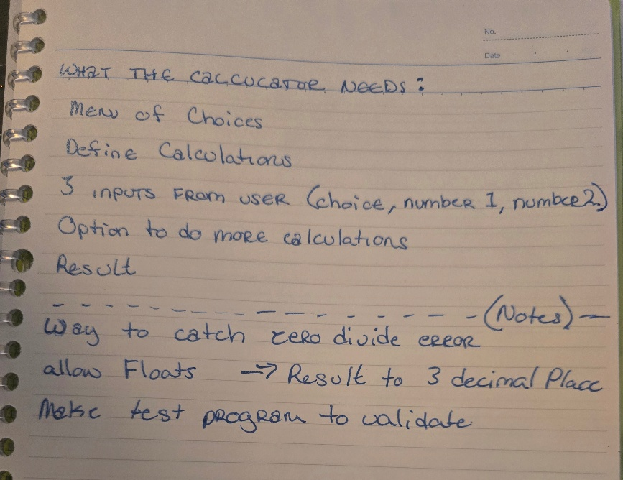
Figure 1: Notes

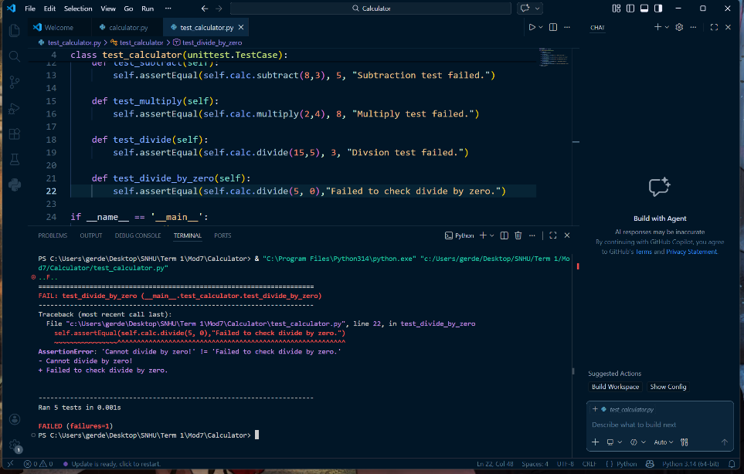

Figure 2:
Test Failed

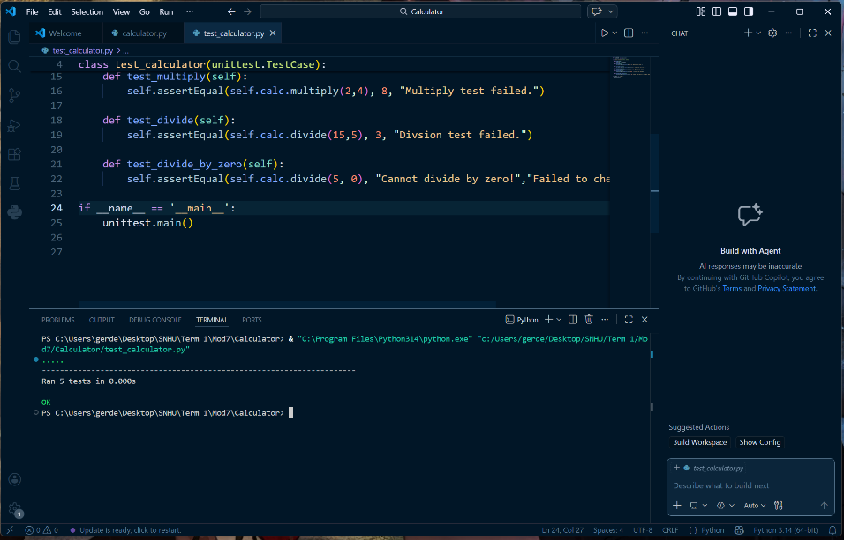
Figure 3:
Test OK

